India tour 14-30 November 2018
Hotel day 12 - 13
Days 12 - 13 Jaipur, located slightly North East of Pushkar145klms some 278klm more fertile desert region of Rajasthan.
Sunday 25th and Monday 26th November 2018. 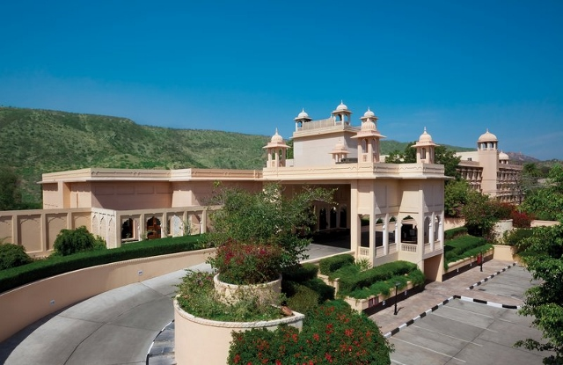
The Trident. Address Amber Fort Road, Opposite, Jal Mahal, Amer, Jaipur, Rajasthan.
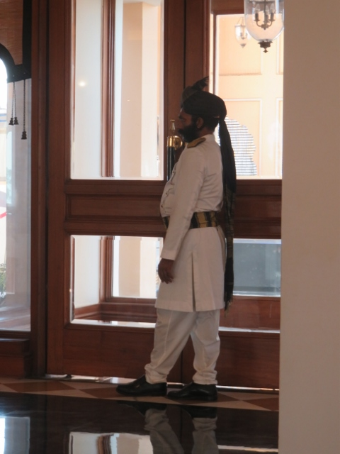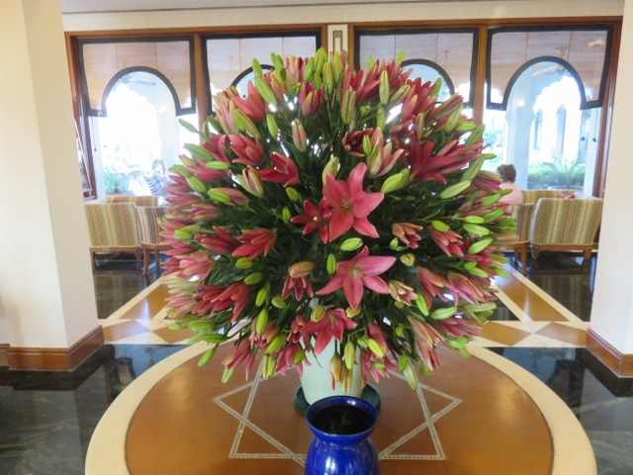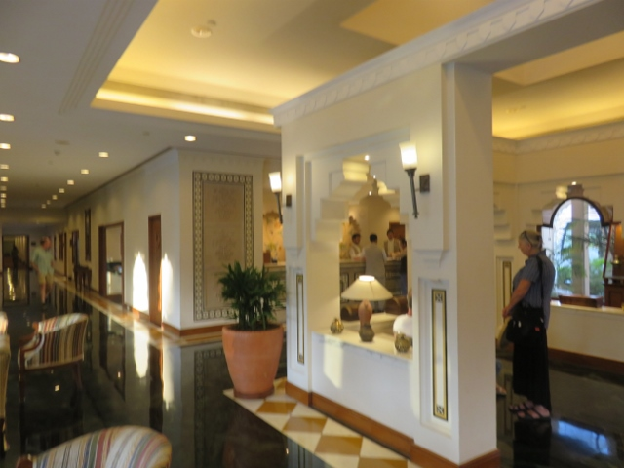
Door Waller to greet guests’ flowers at reception lobby alcove for guests.
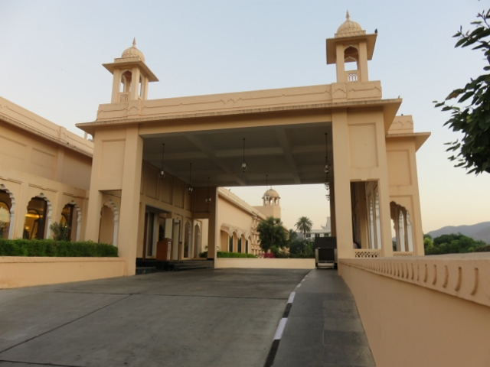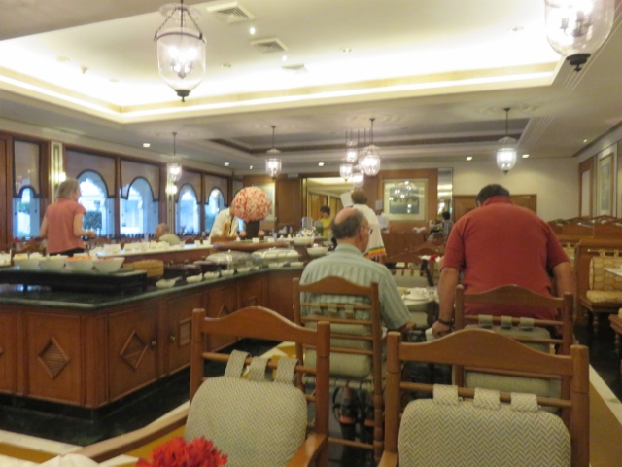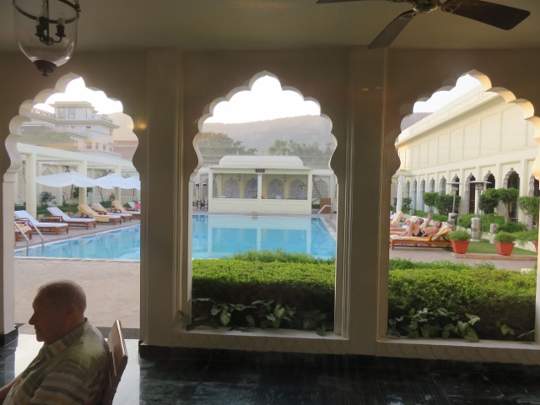
Driveway to receptionception buffet dining room view of swimming pool from lobby.
As can be seen in the background to the hotel promotion photo above the hills are greener than previous stays.
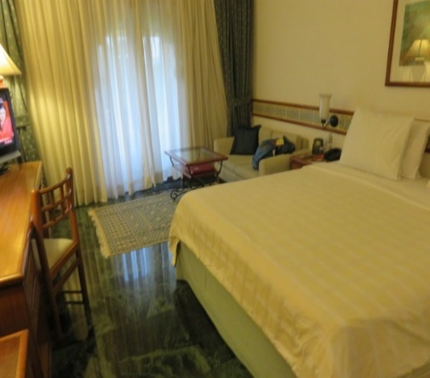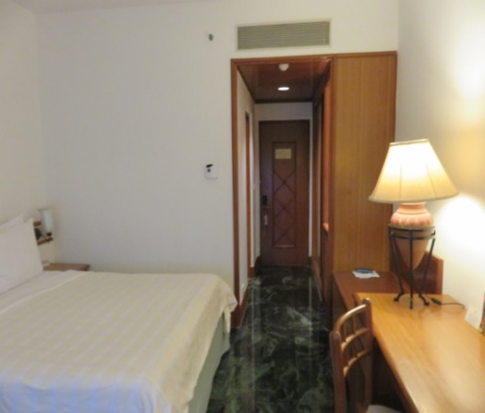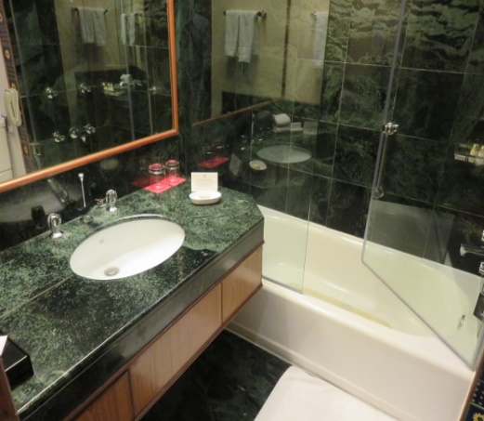
Alan’s room 220 entrance hallway bathroom
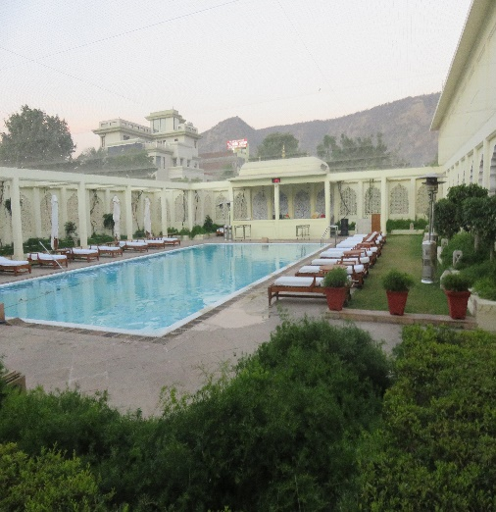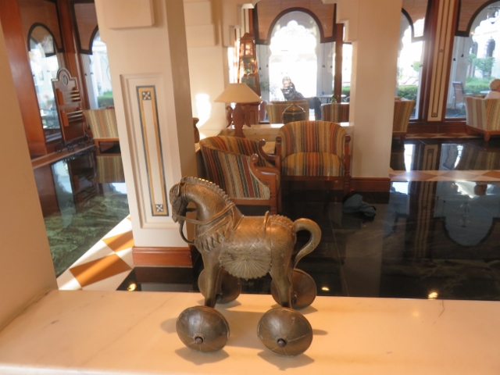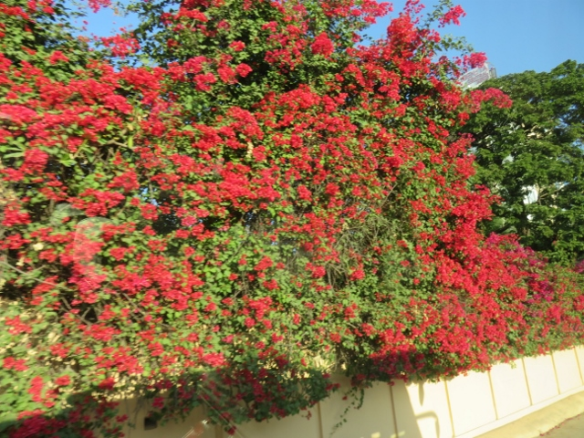
View of swimming pool area. Carved wooden horse in lobby. Bougainvillea near entrance.

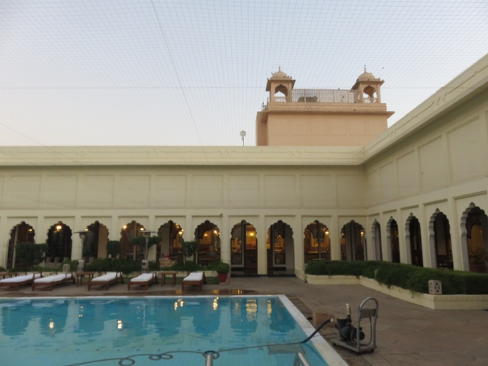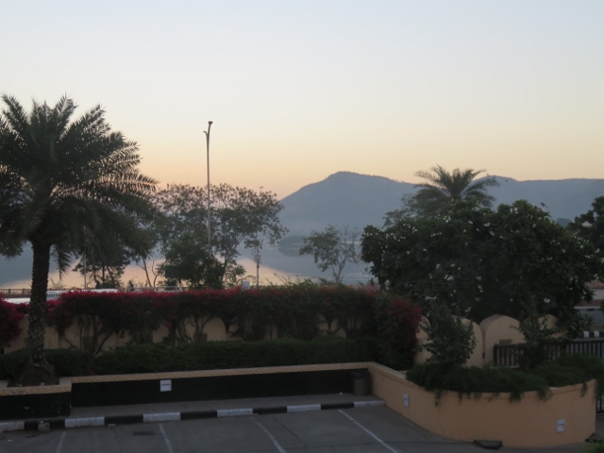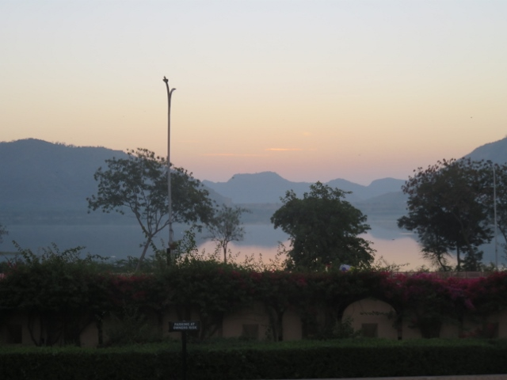
View swimming pool back to lobby early morning scenes looking towards the lake opposite the hotel.

This hotel is the base for the tour to visit (ABF) - read “another blooming fort” – but with a difference. This one is rather special as to get to the top of the formidable defensive ramparts one has to either get a lift with a jeep or ride on the back of an elephant!
From the top of the fort structure there is a view on the surrounding hills of the continuous walled defence that is second only to the Great Wall of China in length. Details will be in the days 12 and 13 journal.

